**User’s Guide**

James Hardiman Library Analytical Application

**Table of Contents:**

**Section 1.**

**3**

**3**

**3**

**5**

**5**

**6**

**7**

**7**

About this application

**Section 2.**

Intended audience

**Section 3.**

Starting the application

**Section 4.**

Working with the application

* Section 4.1 Starting Analysis
* Section 4.2 Choosing Demand Categorisation
* Section 4.3 Selecting Dynamic Loan Period
* Section 4.4 Using Existing Model

**Section 1:**

**About this application:**

This analytical application provides advanced capabilities that library stakeholders can use to gather insights and create recommendations to maintain the highest degree of efficiency from a single point of control. This booklet, the James Hardiman Library Analytical Application User’s Guide, provides information for the operator on using the analytical application as the central point to manage the libraries shelving efficiency and demand categorisation.

**Section 2:**

**Intended audience:**

This application is for use by the National University of Ireland, Galway James Hardiman Library stakeholders.

**Section 3:**

**Starting the application:**

The application opens by default with a pop-up window prompting user to either ‘Run Assignment on New Data’ or ‘Run Assignment on Existing Data’ as shown in Figure 1.

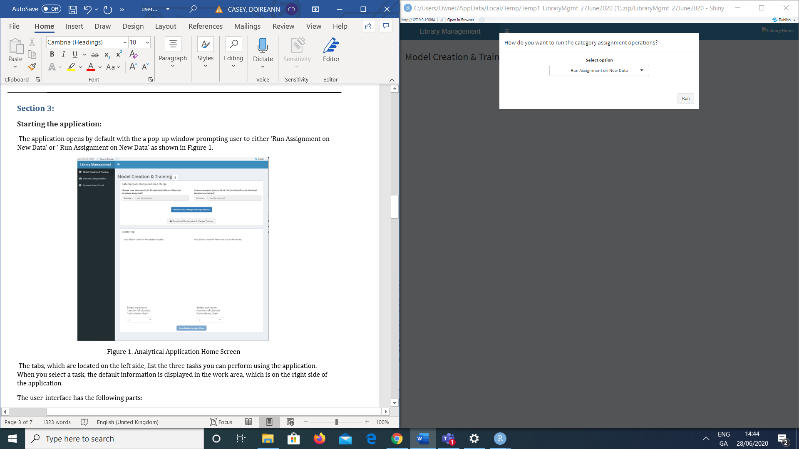

Figure 1. Analytical Application Home Screen

The tabs, which are located on the left side, list the four tasks you can perform using the application. When you select a task, the default information is displayed in the work area, which is on the right side of the application.

The user-interface has the following parts:

* Web Banner
* Title Bar
* Viewer Selection
* NUIG Logo
* Tabs
* Work Area
* Exit

The web banner, shown in Figure 2, is located across the top of the application. This contains the web address for the application, the option to open the application in a chosen browser and a refresh button. Refreshing the application sets the tool to the default start.

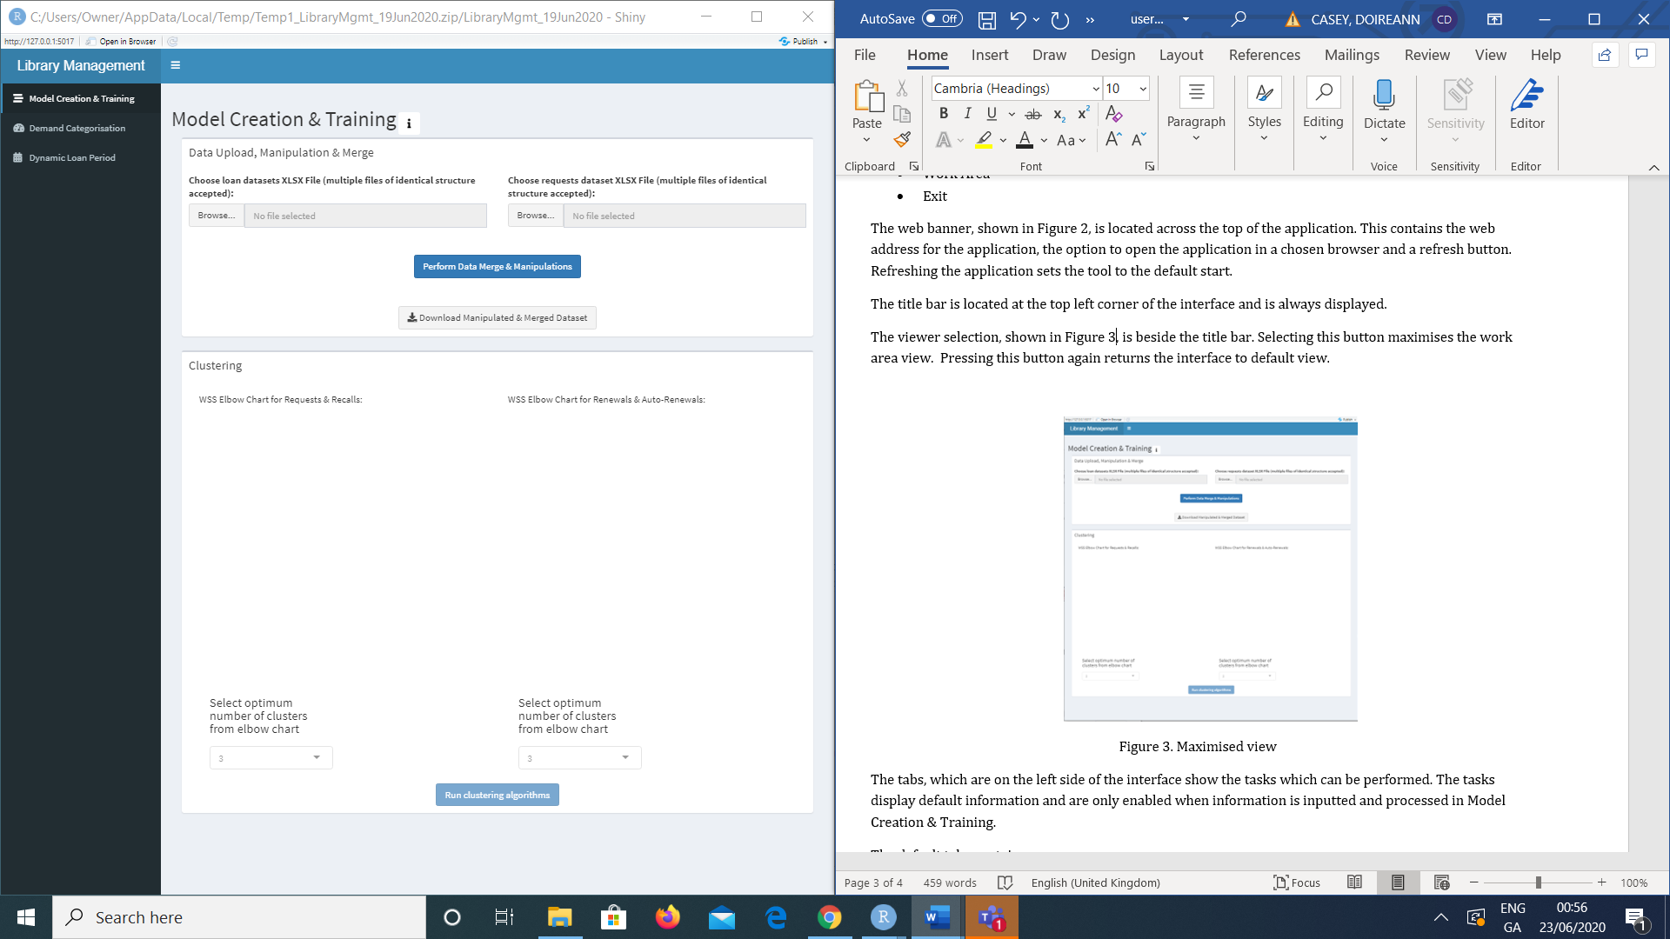

Figure 2. Web Banner

The title bar is located at the top left corner of the interface and is always displayed.

The viewer selection, shown in Figure 3, is beside the title bar. Selecting this button minimises the work area view. Pressing this button again returns the interface to default view.

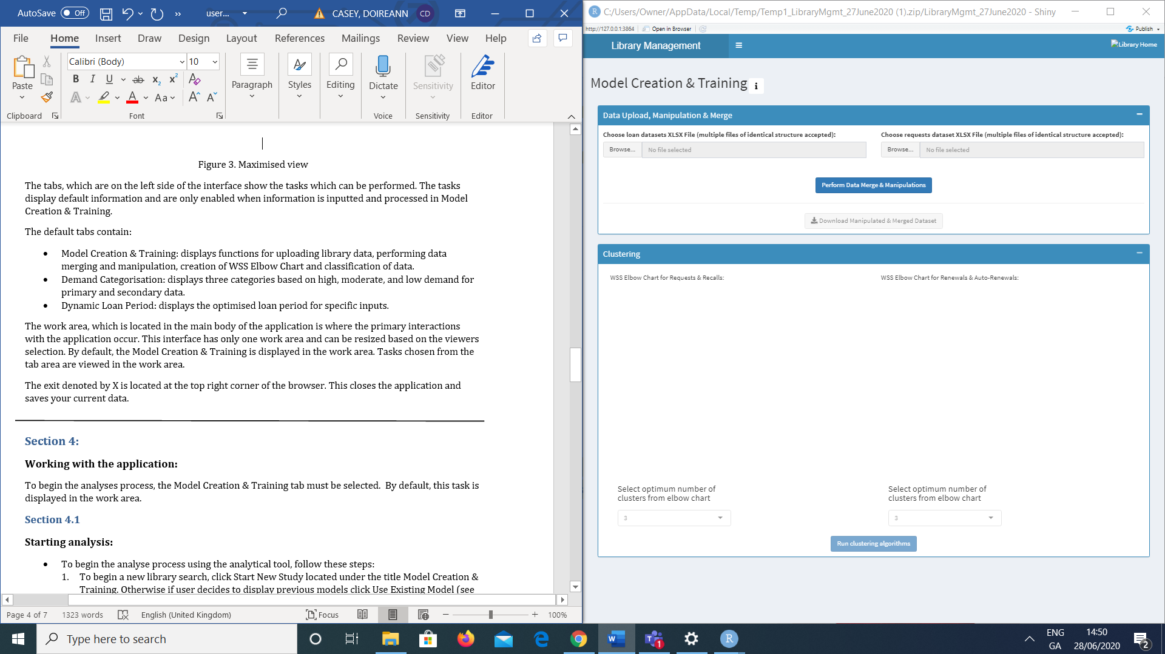

Figure 3. Maximised view

The NUIG logo displayed in the top right corner, takes the user to the James Hardiman Library webpage.

The tabs, which are on the left side of the interface show the tasks which can be performed. The tasks display default information and are only enabled when information is inputted and processed in Model Creation & Training.

The default tabs contain:

* Model Creation & Training – New Data: displays functions for uploading new library data, performing data merging and manipulation, creation of WSS Elbow Chart and classification of data.
* Model Creation & Training – Existing Data: displays functions for running classification and assigning labels for demand categorisation and dynamic loan periods.
* Demand Categorisation: displays three categories based on high, moderate, and low demand for primary and secondary data.
* Dynamic Loan Period: displays the optimised loan period for specific inputs based on Requests & Recalls and Renewals and Auto-Renewals.

The work area, which is located in the main body of the application is where the primary interactions with the application occur. This interface has only one work area and can be resized based on the viewers selection. By default, the Model Creation & Training is displayed in the work area. Tasks selected from the tab area are viewed in the work area.

The exit denoted by X is located at the top right corner of the browser. This closes the application and saves your current data.

**Section 4:**

**Working with the application:**

To begin the analyses process, the Model Creation & Training tab is automatically displayed based on the users selection whether to use new or existing data . By default, this task is displayed in the work area.

**Section 4.1**

**Starting analysis:**

* To begin the analyse process using the analytical tool, follow these steps:

1. To begin a new library search, click ‘Run Assignment on New Data’ in the default pop-up window. Otherwise if user decides to display previous models click ‘Run Assignment on Existing Data’ (see Section 4.4).
2. Having selected to use new data, the interface automatically displays the Model Creation & Training task in the work area. The user must input their data files into the field titled ‘Data Upload, Manipulation, & Merge.’ This field is divided into two upload categories: Loan datasets and Requests datasets. Using the browse function, the user can select files from their computer. See Figure 4.

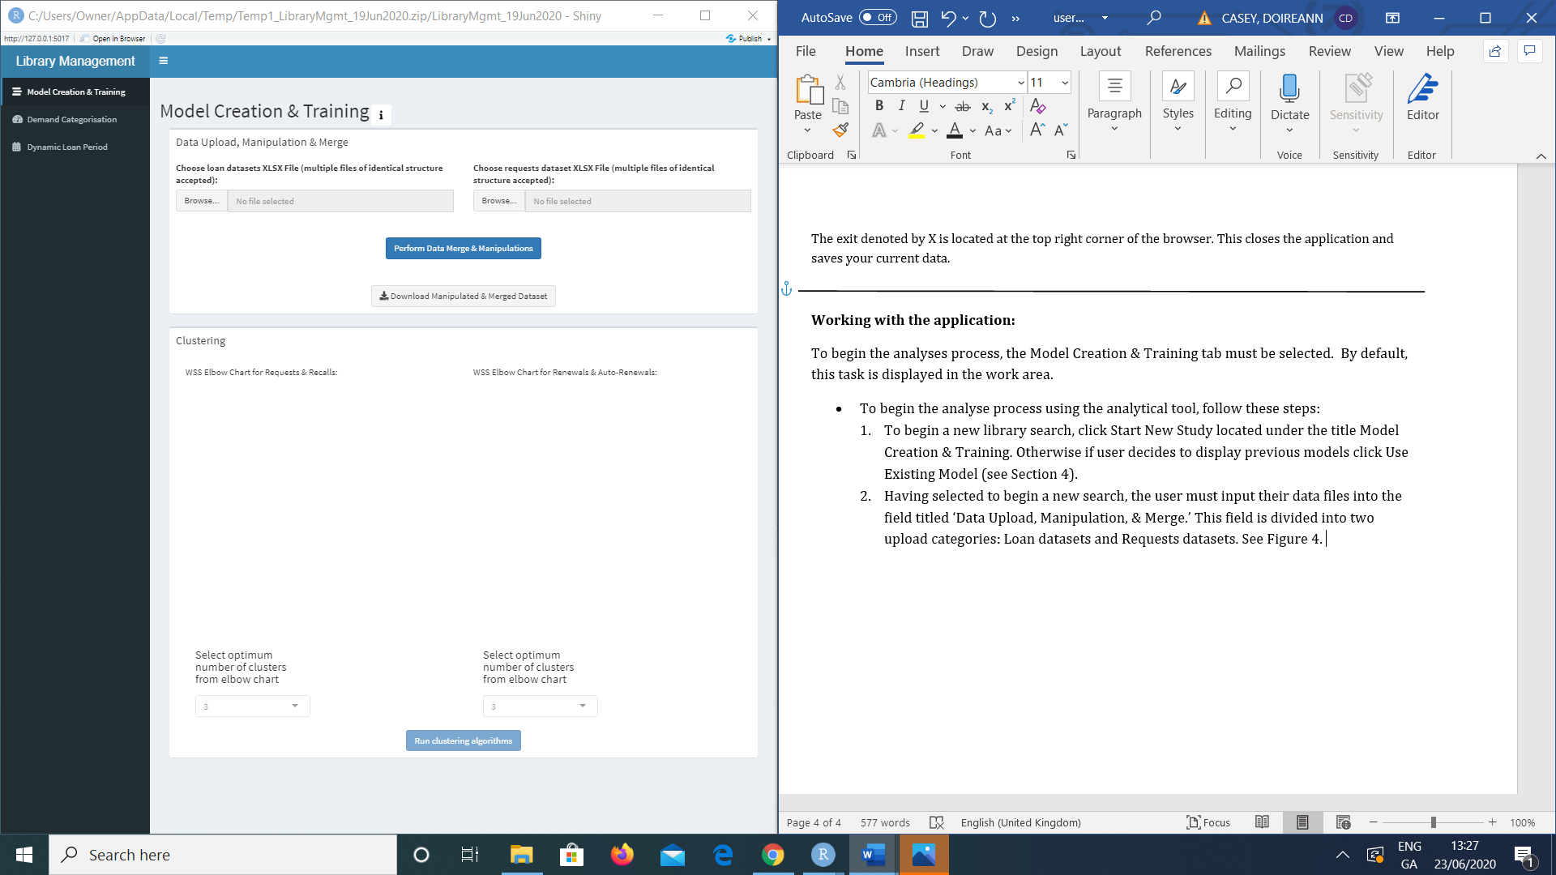

Figure 4. Data upload fields.

**Note: files must be in XLSX format.**

1. Toggling the ‘Perform Data Merge & Manipulations’ button begins the merging process. A loading bar appears in the bottom right corner which visualises the progression of the operation. When the task is accompolished a pop-up will appear to confirm success.
2. In the event of an unsuccessful operation, the pop-up will inform user of the error.
3. Now the ‘Perform Data Merge & Maniupulations’ have taken place, the download button is now enabled for the user to download the results.

**Note: these files do not go to prefixed folder, the user must select the folder.**

1. The computed data from steps 2-3 are now analysed in the field titled ‘ Clustering.’ This field is divides into two categories of WSS charts: Requests & Recalls and Renewals and Auto-Renewals.
2. Below each chart, the number of clusters can be toggled from 3-14 using the drop-down function. The optimum cluster is usually indicated by the location of a bend (elbow) in the plot.
3. Toggling the ‘Run clustering algorithms’ button begins the clustering for the next process. When the clustering is complete, a pop-up appears to confirm operation execution. The results are displayed in a field titled ‘Category Assignment.’
4. This field computes the data for the specfied number of clusters selected in step 7. Based on the number of selected clusters, the user must now specify demand categories and dynamic loan levels for each cluster. See Figure 5.

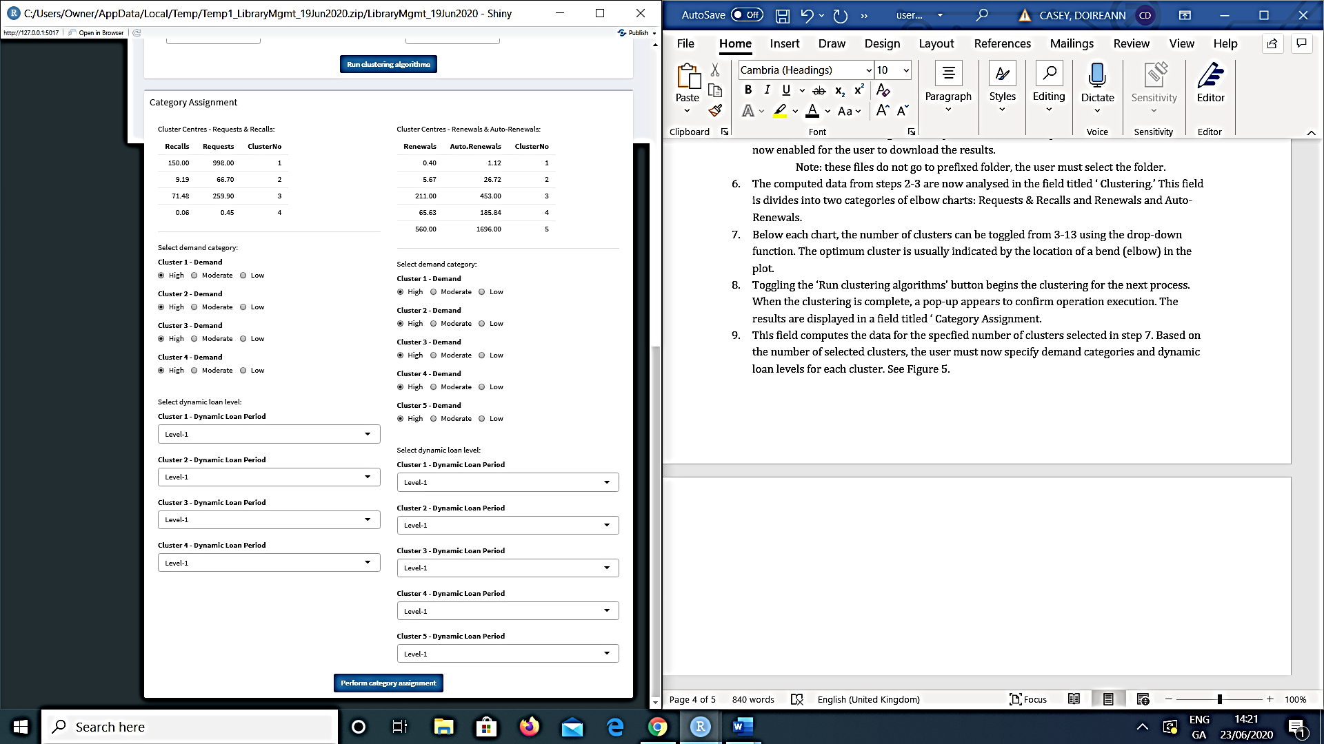

Figure 5: Category Assignment.

**Note: sample is using 4 clusters.**

1. To complete the category assignment process, click ‘ Perform category assignment.’ A loading bar appears in the bottom right corner which visualises the progression of the operation. When the task is accompolished a pop-up will appear to confirm success and the results of this process are saved to a csv file. A new field titled classification is now visible.
2. The classfication field classfies the data from steps 2-10 and is performed using the ‘run asset classification’ button. When the task is accompolished a pop-up will appear to confirm success.
3. The outcome of this process is displayed under ‘view generated decision trees.’
4. The user must now sumbit their datafiles produced in step 10. This field is divided into two upload categories: Loan datasets and Requests datasets. Using the browse function, the user can select files from their computer.
5. The user must select ‘Assign demand & dynamic loan labels’ and can now proceed to Section 4.2 and 4.3 by selecting their preferred option in the pop-up window.

**Section 4.2**

**Choosing Demand Categorisation**

* Based on the completetion of the first task ‘Model Creation & Training’, the tabs are now enabled for analysis purposes. To operate ‘Demand Categorisation’ follow these steps:

1. Having selected demand categories based on the chosen clusters in Section 4, these now appear under this task.
2. Demand is categorised into two categories Primary and Secondary Demand and three sub-categories based on the demand categorisation: High, moderate, and low. See Figure 6.

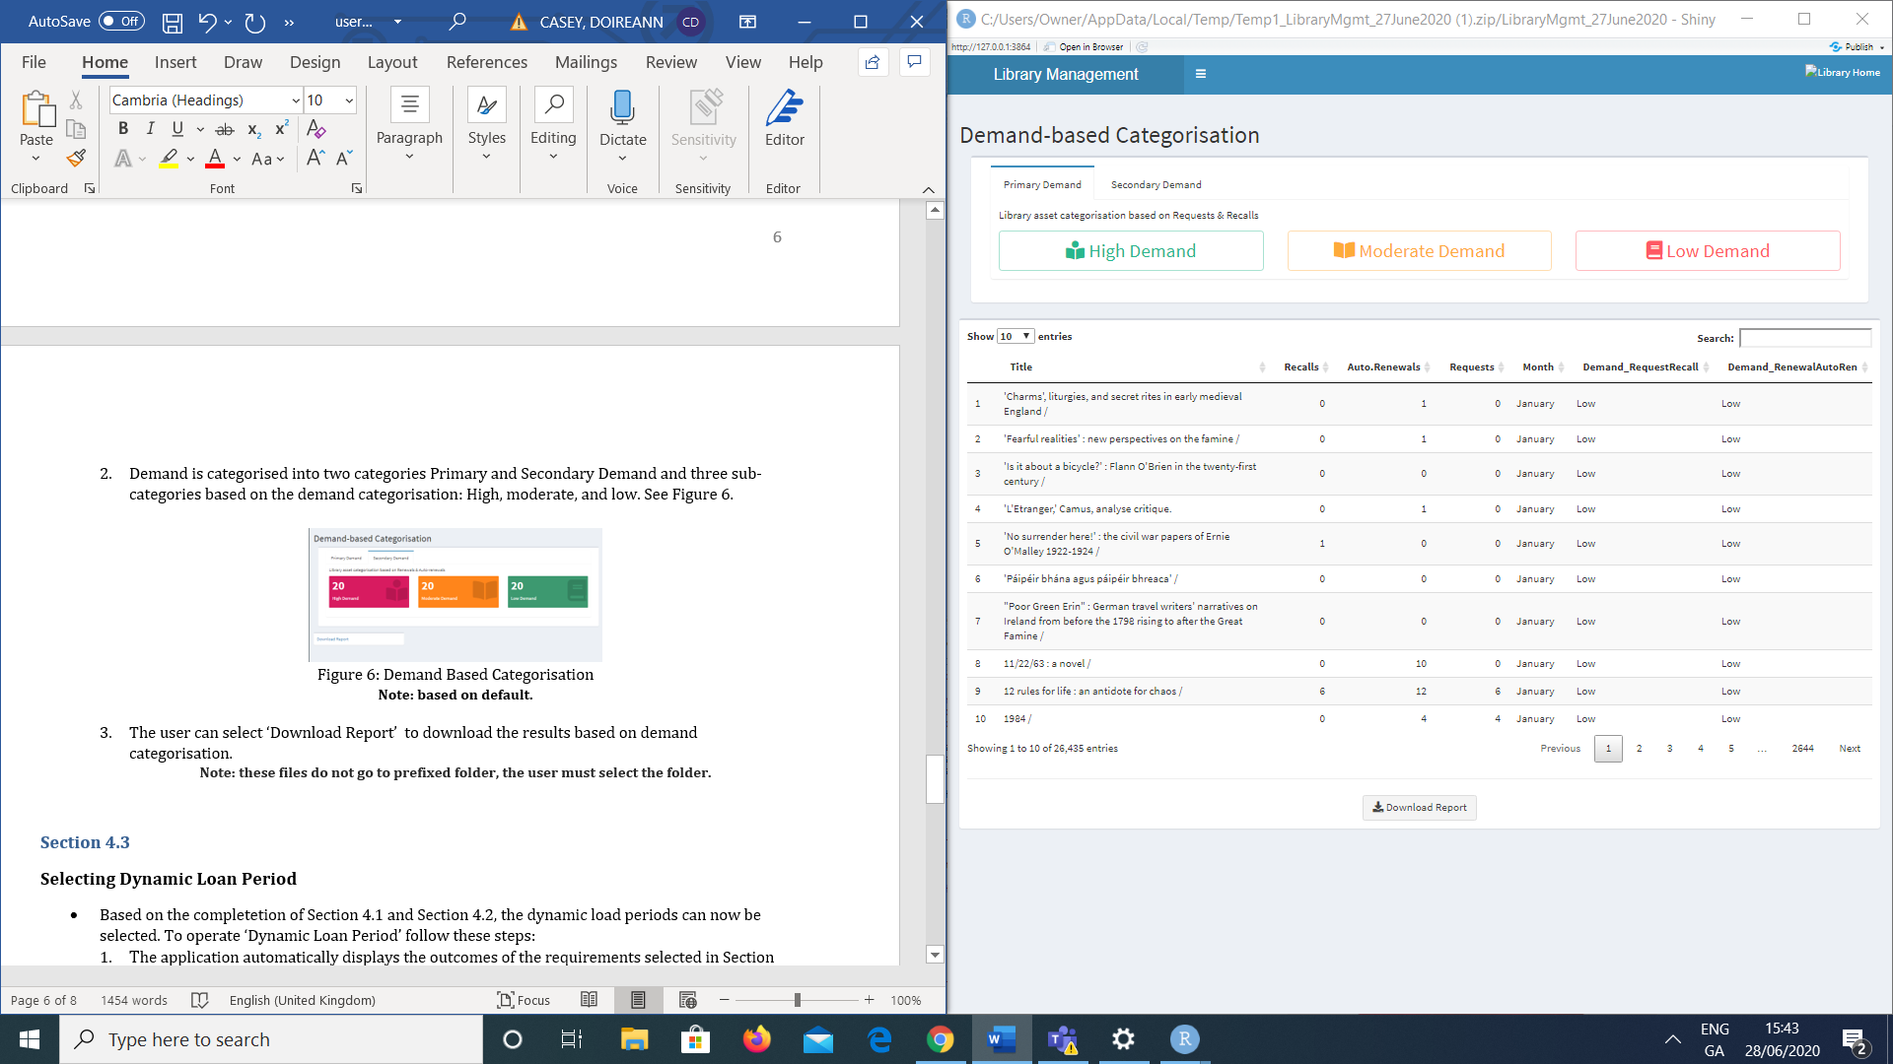

Figure 6: Demand Based Categorisation

**Note: based on default.**

1. By selecting the categories shown in Figure 6, the entries are displayed as per demand category in a pop-up window. The entries are also shown in the work-area and can be sorted using the dropdown beside each column.
2. The user can select ‘Download Report’ to download the results based on demand categorisation.

**Note: these files do not go to prefixed folder, the user must select the folder.**

**Section 4.3**

**Selecting Dynamic Loan Period**

* Based on the completetion of Section 4.1, the dynamic load periods can now be selected by the user. To operate ‘Dynamic Loan Period’ follow these steps:

1. The application automatically displays the outcomes of the requirements selected in Section 4.1.
2. The loan periods are categorised into 4 levels based on the users selection i.e a book in high demand might be assigned to level 1.

**Note: Loan period is based on number of clusters selected and demand categorisation**

1. The loan periods can be filtered between Requests & Recalls or Renewals & Auto-Renewals. The drop down shown in Figure 7, displays the specifed loan levels for primary or secondary data that can be selected. The specifed entries are shown in the work area and can be sorted using the dropdown beside each column.

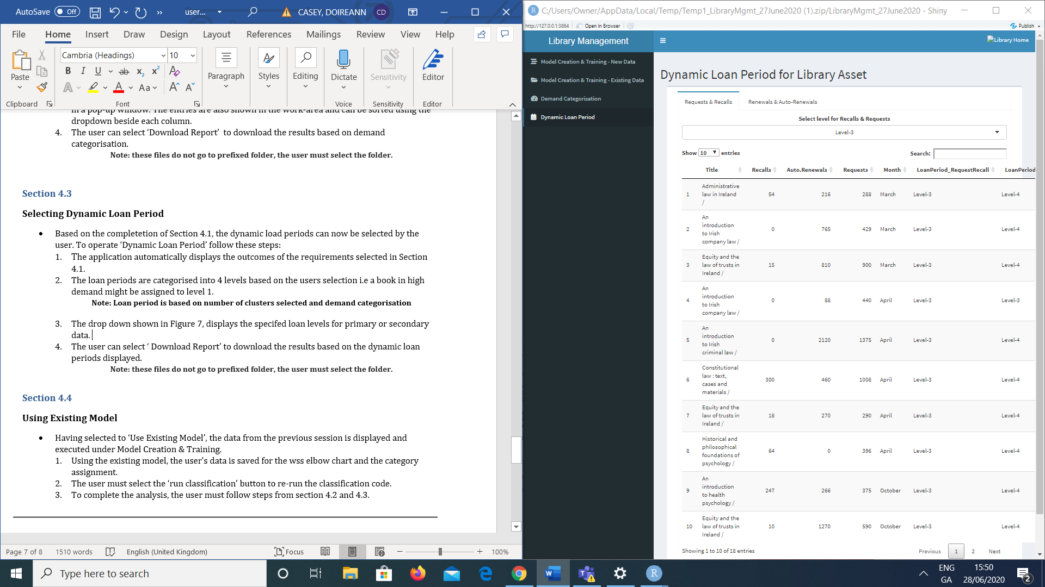

Figure 7, Dynamic Loan Period for Library Asset

1. The user can select ‘ Download Report’ to download the results based on the dynamic loan periods displayed.

**Note: these files do not go to prefixed folder, the user must select the folder.**

**Section 4.4**

**Using Existing Model**

* Having selected to ‘Run Assignment on Existing Data’ upon opening the application, the data from the previous session is displayed and executed under Model Creation & Training – Existing Data task.

1. Using the existing model, the user must select the ‘run asset classification’ button to re-run the classification code.
2. The outcome of this process can be displayed by selecting to ‘view generated decision trees.’
3. The user must now submit their exisitng datafiles from the clustering process from the previous session. This field is divided into two upload categories: Loan datasets and Requests datasets. Using the browse function, the user can select files from their computer.
4. To complete the analysis, the user must follow steps from section 4.2 and 4.3.